Servo control board instructions V1.3

# Features

● 32-bit ARM core processor chip

● unique online upgrade mechanism, the user can upgrade the firmware online

● Automatic baud rate

● the use of USB and UART communication interfaces

● 1us control precision (equivalent to 0.09 degrees servo)

● can simultaneously control 32 synchronous servo (24-channel synchronous servo control board can simultaneously control up to 24, 16 servo control board can simultaneously Synchronization control 16 servos)

● Built-in 512K memory chip can store hundreds of action group

● powerful computer software (built-in 3 languages, Simplified Chinese, Traditional Chinese, English)

● have an Android phone control software (in conjunction with a Bluetooth module)

# powered by

Servo control board requires two power: servo power and chip power (servo power is relatively large, it is not recommended to share a power supply)

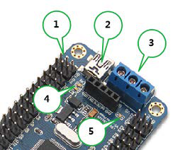

Servo power source (positive): VS (FIG. 3 position of the right end of the blue terminals)

Power steering (negative): GND (blue in Fig intermediate terminals No. 3 position)

Servo parameters according to the actual power of the connected servo parameters may be, such as TR213 servo supply voltage is 4.8-7.2V, then the servo power supply can be used in a power supply voltage between 4.8-7.2V.

Chip power supply (positive): VSS (FIG. 3 position of the left end of the blue terminals)

Chip power supply (negative): GND (blue in Fig intermediate terminals No. 3 position)

VSS requirements are 6.5-12V, if the chip is powered from the input port VSS, then the power supply voltage must be between 6.5-12V.

Also:

1. Figure No. 2 position in the USB interface to the chip power supply, so the USB interface port and VSS, you can choose one.

2. Figure No. 1 position for the chip to be powered marked 5V and GND, 5V is positive, GND is the negative power supply voltage must be 5V.

**3. Figures in 1,2,3 position can give the chip power supply, you can choose one. (However, in strict accordance with the scope of their power)**

4. Figure No. 4 position green LED chip supply is normal lights, green lights that chip supply is normal, the green light is off, the chip power anomalies.

5. Fig. 5 position the green LED is normal servo power indicator lights green, indicating normal power steering, the green light is off, the steering gear power anomalies.

**If you need to control the steering gear, two green LED lights are lit is a prerequisite.**

# install driver

Driver Download: http://www.torobot.com/down/usc_driver.exe (all lowercase)

Simply double-click usc_driver.exe, click Next to install the driver.

Driver installation process if the following prompt appears, select "Install this driver software."

<insert image here>

Driver installation process if the following prompt appears, select "Continue."

<insert image here>

After a successful driver installation, enter the computer's device manager, then you can see the servo control board hardware device, as shown in the mini

USB servo control is the device name, COM472 is the port number (port number that each computer display are not the same), the use of computer software

Member steering control when the need to know the port number of the device.

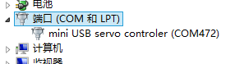

# Connect the servo to servo control board

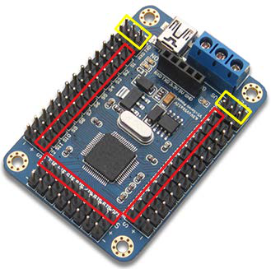

The red markers are servo signal wire interface (when connected to the steering gear to pay attention to the direction)

Not a servo interface The yellow markers

Even when the attention of the steering gear next to white text markers, such as S1, S2 ..... S32, on behalf of the servo channel with the computer software is one to one.

# Download software

Software Download: http://www.torobot.com/down/rios_usc.exe (all lowercase)

# Controlling a single servo

Run rios_usc.exe, then select the correct port number (can not pick), then click the button "Open."

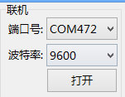

Then use the mouse to drag the slider panel servos (servo connections is the first of several channels, it is necessary to drag the corresponding steering panel, the top panel is numbered as shown in S1)

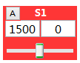

(Digital frame panel on the left is the current output of the PWM pulse width, the right frame temporarily without any sense)

# Simultaneous control of multiple servos

After following the above steps sequentially control multiple servos, then set the time (in the following figure, the set is 1000ms, on behalf of the steering gear rotational speed range must be between 100-9999, the greater the value the slower), then click on the bottom of the software the "Add" button, then the software will generate a command below, which commands can simultaneously control all front steering control (if control of the front steering gear 10, which then can simultaneously command this control 10 servos).

After modification, you can continue to "add" several times, each "Add" once the action on behalf of a robot.

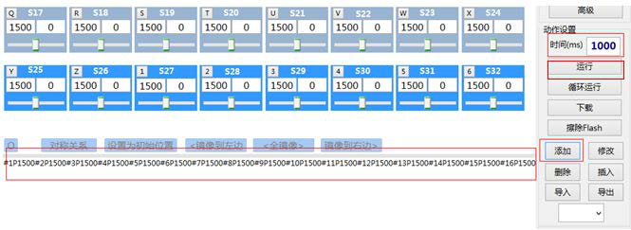

# Download Action Group

Follow the steps above, the production of a few or dozens of command after the software by clicking on the right side of the "Run" button to test the effect of command.

If the results are no problem, you can click the right side of the software "download" button to download the action group.

After a successful download, the software will prompt "download is complete! No. = 1", prompt action figure is the group number.

After only need to perform this action group, you can perform all the commands of the action following the group.

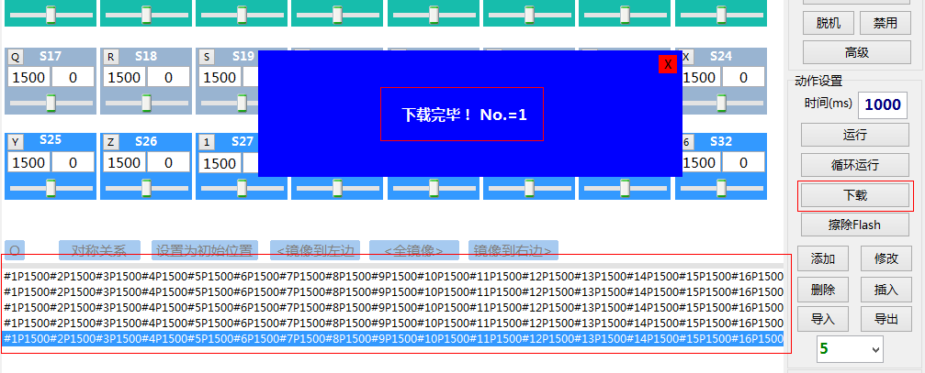

# Perform an action group

First click "Read" button to get all the work group number, then enter the number of times you need to perform, and then click the button "execute", you can perform the selected action group.

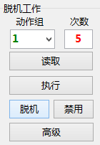

# Work Offline Use

First click "Read" button to get all the action group number, then enter the number of times you need to perform, and then click the button "offline", you can set the selected action group performed offline meaning (it is performed offline after the control circuit board will be performed).



If the control panel is not required to work offline, you can click on the button "Disable" to turn off the offline functionality.

# Erase Flash

Remove dashboard already downloaded all the action groups.

# Panel Settings

Click the upper-left corner of the "Panel Settings" -> Panel edit mode. In this mode, you can drag the position 32 of the panel, click on the button to hide & display the corresponding panel.

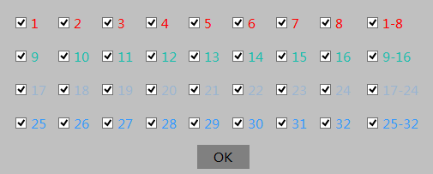

Click the "X" position after the panel will automatically save and display the hidden information.

Secondary Development

Servo control board is a slave, which is the only accepted command, or execute a command set well in advance, can not have thinking ability. Communication protocols: serial communication (TTL level), 9600 baud, no parity, 8 data bits, 1 stop bit

Users can develop their own computer software to send commands to the steering gear control panel, you can also use the microcontroller to send commands to the servo control board, which is controlled by the steering servo control board.

**Format:**

|  |  |  |
| --- | --- | --- |
| **name** | **command** | **Explanation** |
| Controlling a single servo | #1P1500T100\r\n | 1 is a servo data channel  1500 data is the position of the steering gear, in the range of 500-2500  Data 100 is a time to perform, showing the speed range is 100-9999 |
| Control multiple servos | #1P600#2P900#8P2500T100\r\n | 1,2,8 is servo data channel  Data 600,900,2500 are three channels of servo position  Data 100 is the execution time is three servo speed, regardless of the number of servos is how much time can be only one, that is, only one T. The command is executed simultaneously, that is, all the servos are moving together. |
| Perform a single action group | #1GC2\r\n | 1 is an operational data set number  Data 2 is the number of cycles |
| Perform multiple action group | #1G#3G#1GC2\r\n | Followed by implementation of an action group, the first three action groups, the first one action group, the number of cycles is 2 times.  With a set of actions can be repeated cycles only have one, which is the only one of the C command is executed sequentially, that is, the action group is performed sequentially according to the order. |

The above command has one thing in common, there \ r \ n, this is the command terminator, have to have.

All commands are no spaces.

\r\n is two characters, the carriage return and line feed, a hexadecimal number 0x0D and 0x0A, is Chr (13) and Chr (10).

Connection with the microcontroller

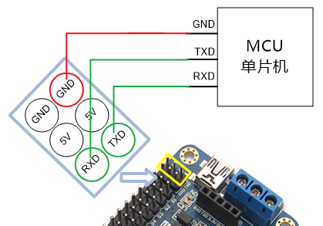

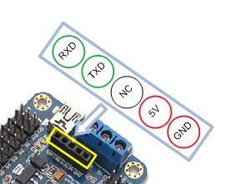

contact us

Service Phone: 4008865055

Email:shen@torobot.com

QQ:621849199

Have any questions you can contact us through the above manner, you can contact other agents.